Simulated Venipuncture / Specimen Handling
This lesson is available free for all under the Creative Commons Attribution 4.0 International License (CC BY 4.0).
Activity Title: Simulated Venipuncture / Specimen Handling
Date: May 2026

Overview

Summary
This activity introduces participants to simulated venipuncture and specimen handling techniques commonly used in healthcare settings. Activity participants will locate and access simulated veins, obtaining a simulated blood specimen, handling and labeling specimens appropriately, practicing infection control procedures, and safely disposing of sharps. The activity also introduces participants to healthcare careers that utilize venipuncture and specimen collection skills.

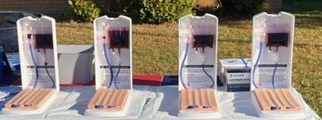
Careers Associated
- Phlebotomist
- Medical Laboratory Technician (MLT)
- Medical Laboratory Scientist (MLS)
- Licensed Practical Nurse (LPN)
- Registered Nurse (RN)
- Emergency Medical Technician (EMT)
- Paramedic

Supplies Required

General Setup
- Tables or large work surface
- Chux pads, absorbent pads, or puppy pads for table protection
- Trash can
- Sharps container
- Venipuncture training aid/arm prefilled with simulated blood
- Cleaning/disinfecting supplies
- Band-Aids available in case of accidental poke
- Additional needles/adapters available in case students miss the vein initially

Per Participant
- One pair of nitrile gloves
- Butterfly needle connected to adapter or straight Vacutainer needle with luer lock adapter.
- Alcohol wipe
- 2x2 gauze
- Patient labels
- Biohazard specimen bag
- Vacutainer tube or multiple tube colors for advanced participants
Time Required
- Setup: Approximately 10 minutes prior to participant arrival
- Instruction/Demonstration: Approximately 3 minutes
- Activity: Approximately 10 minutes per participant/group
- Initial Cleanup on Site: Approximately 5 minutes
- Trainer Cleaning/Restocking After Event: Approximately 30–45 minutes
Total Estimated Time: Approximately 1 hour including setup and full equipment cleaning. Participant-facing activity time is approximately 20 minutes.
Target Audience
- Recommended for grades 7 through adulthood
- Intended primarily for healthcare career exploration activities
- Appropriate for beginners and healthcare pathway exploration students

Learning Outcomes
Participants will:
- Demonstrate basic simulated venipuncture technique
- Practice infection prevention and control procedures
- Demonstrate safe specimen handling and transport practices
- Properly label and package a specimen
- Understand the importance of patient identification and specimen accuracy
- Explore healthcare careers that use venipuncture and laboratory collection skills

Setup
- Arrange venipuncture stations around a large table so all participants can observe demonstrations.
- Place absorbent pad or protective covering on each table surface.
- Position venipuncture trainer on top of protective pad.
- Trainers should be filled with simulated blood/cleaned before participant arrival.
- Ensure all supplies are organized and accessible at each station.
- Verify sharps container is present and easily accessible.

Introduction
Explain to participants that they will be practicing simulated venipuncture, a skill commonly used in healthcare settings to obtain blood specimens for laboratory testing.
Discuss how this skill is utilized by a variety of healthcare professionals including nurses, phlebotomists, EMTs, paramedics, and laboratory professionals.
Review infection prevention concepts, specimen identification importance, and sharps safety prior to beginning the activity.

Steps to the Activity
- Participants put on gloves.
- Discuss purpose of gloves, infection prevention, and normal skin flora.
- Students identify an appropriate simulated vein on the trainer.
- Clean selected area with alcohol wipe.
- Explain vein options on the trainer, including small, medium, large, and deep veins when applicable.
- Open blood collection set and discuss contamination prevention.
- Connect Butterfly access device to infusion set OR connect straight vacutainer needle and adapter. Do this together as a group with facilitator connecting simultaneously.
- Carefully uncap needle, I warn to expect “real needle”
- Insert needle bevel-up at approximately a 15–30-degree angle into selected simulated vein.
- Push vacutainer tube into adapter.
- Observe simulated blood filling the specimen tube.
- If blood return is not seen, explain that students may have gone through the vein and should slowly back the needle out slightly.
- Label specimen tube.
- Discuss patient verification and importance of avoiding specimen misidentification.
- Place labeled specimen into biohazard bag.
- Withdraw needle safely while placing gauze over insertion site.
- Dispose of sharps immediately into sharps container.
- Remove gloves and dispose appropriately- Students may take simulated blood home to show family and further discuss Healthcare Career exploration.

Safety / Protocols / Special Considerations

Needle and Sharps Safety
- Real needles are used for this activity.
- A sharps container must always be present and accessible.
- Needles should never be recapped.
- Participants should receive direct supervision during needle handling.
- Facilitators should review proper sharps handling before beginning.
- Bandages and basic first aid supplies should be available in case of accidental poke.
- Younger participants may require additional supervision and support.

Blood and Infection Control Considerations
- Simulated blood is used.
- Gloves are required during the activity to add realism and protect against skin staining.
- Infection prevention and contamination prevention should be discussed throughout the lesson.
- Participants should avoid touching cleaned insertion areas after alcohol preparation.

Accessibility Adaptations
- Participants uncomfortable with needles or blood may observe instead of actively participating.
- Facilitators may demonstrate portions of the activity for participants with physical limitations.
- Alternative observation-only roles such as specimen labeling or packaging may be offered.
- Additional facilitator support may be needed for younger students or participants with fine motor limitations.

Audience Considerations
- Because real needles are used, facilitator discretion should be used for younger audiences.
- Participants should be informed ahead of time that needles and simulated blood are involved.
- Participation may be optional for students uncomfortable with medical procedures.
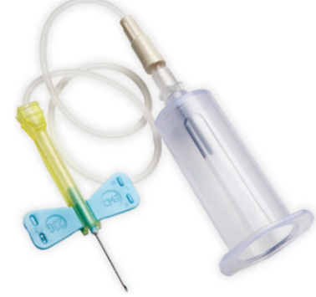

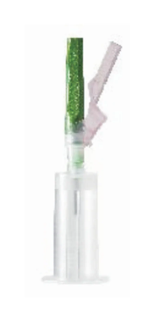
Assessment of Success
Success may be measured by participants’ ability to:
- Demonstrate safe sharps handling
- Correctly identify and access a simulated vein
- Successfully obtain simulated blood return
- Properly label and package a specimen
- Follow infection prevention procedures
- Demonstrate professionalism and communication during the activity
- Feel a sense of accomplishment an “I can do this” motivating feeling.

Lessons Learned / Helpful Tips

Lessons Learned
- Students commonly advance the needle too far through the vein; backing the needle out slightly often corrects the issue.
- Having extra needles and adapters available is important because many beginners miss on the first attempt.
- Smaller groups work best unless additional facilitators are present as some participants need more help.
- Students are often highly engaged and excited by the realism of the activity- Definitely a crowd Favorite!
- Creating patient labels that are names/birthdates of popular actors/musical artists has added a lot to student engagement.
- Hospitals and Laboratories will often donate expired Vacutainer tubes or needles for use. I am sure to tell students that are frustrated if they are unable to obtain blood that we are utilizing expired tubes so it might not be necessarily user error so they don’t lose confidence.
- *Important- with younger participants avoid using Vacutainer tubes containing Heparin or other substances in case of ingestion (Red tubes contain no additive)

Helpful Tips
- Prime trainers before activity start to reduce downtime.
- Arrange participants around a large central table so demonstrations are visible.
- Keep extra absorbent pads /paper towels available for leaks or spills.
- Having multiple Vacutainer tube colors and teaching older or advanced participants the correct order of draw can add to this activity.
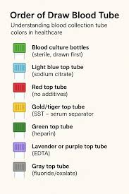
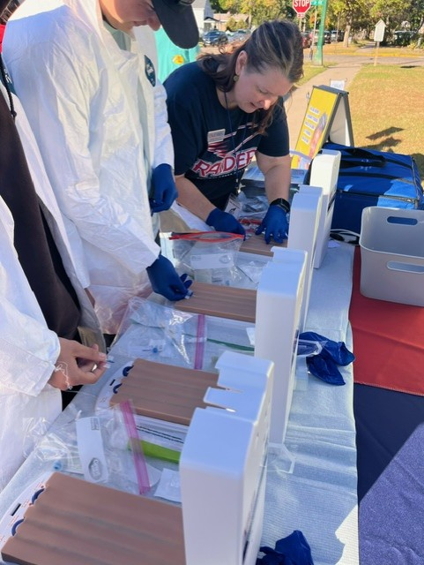

Conclusion

Closing Discussion
As participants finish the activity, discuss their experience and answer questions about healthcare careers that use venipuncture skills.
Encourage discussion regarding professionalism, patient interaction, infection prevention, and the importance of accurate specimen collection.

Clean Up
- Close trainer valves and secure equipment before transport according to device instructions.
- Dispose of sharps appropriately.
- Dispose of used gloves, gauze, wipes, and absorbent pads.
- Clean and disinfect trainers
- Refill trainers with simulated blood as needed.
- Inspect trainers and tubing for leaks or damage.
- Restock all supplies before the next event.

Storage and Transport Notes
- Trainers should be transported securely to avoid leaks or tubing damage.
- Trainers should be prefilled with Simulated blood before events.
- Store sharps containers safely during transportation.
- Do not store trainers in vehicle with extreme temperatures high or low.
