Simulated Intramuscular Injections
Activity title: Simulated IM injections
Date: June 2026

Overview
This activity introduces participants to medication administration through simulated intramuscular (IM) injections. Participants learn how healthcare professionals safely prepare medications, select appropriate injection equipment, draw medication from a vial, and administer an injection into simulated muscle tissue.
Begin with the following discussion or similar:
"There are many ways to administer medication to a patient including oral, intravenous, topical, and injectable routes, just to name a few. Injections can be given just under the skin (intradermal), into the subcutaneous layer of tissue (subcutaneous injections), or deep into the muscle (intramuscular injections). The needle length, needle gauge, and angle of insertion differ depending on the type of injection being administered."
This activity provides participants with a realistic hands-on experience while reinforcing medication safety, infection prevention, and sharps safety. It can be adapted for elementary career awareness through adult healthcare career exploration programs.

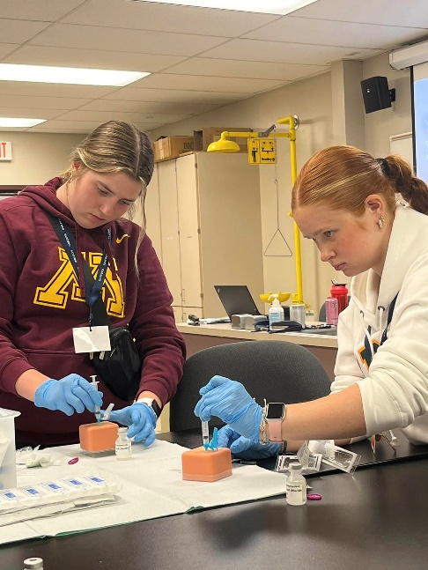
Careers Associated:
• Licensed Practical Nurse (LPN)
• Registered Nurse (RN)
• Medical Assistant (MA)
• Paramedic
• Aesthetic Nurse
• Nurse Practitioner (NP)
• Physician Assistant (PA)
• Physician (MD/DO)
• Pharmacist

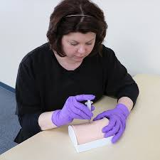
General Setup
• Chux pads or disposable protective barriers
• Tables or workstations
• Injection practice pads, oranges, or medical manikins with injection capabilities
• Sharps containers
• Hand hygiene supplies
• Waste receptacle

Per Participant
• Sterile water vial (20 mL multi-dose vial recommended)
• 1 mL syringe
• Appropriate needle for IM injection practice
• Alcohol swabs
• Gloves (various sizes available)
• Injection practice pad, orange, or access to manikin
• Bandages (in case of accidental needle stick)

Optional Advanced Activity Supplies
• Simulated medication labels
• Medication Administration Records (MARs)
• Patient scenarios
• Multiple medication strengths requiring dosage calculations
• Simulated Provider orders

Time Required
• Setup: 10–15 minutes
• Introduction and Demonstration: 10 minutes
• Activity: 15–20 minutes depending on group size
• Discussion and Cleanup: 5–10 minutes
Total Estimated Time: Approximately 30 minutes

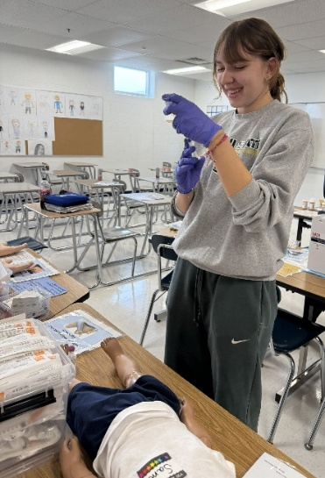
Target Audience
• Recommended for grades 7 through adulthood
• Healthcare career exploration programs
• High school healthcare classes
• Community career exploration events
• Workforce development programs

Learning Outcomes
Participants will:
• Describe multiple routes of medication administration
• Differentiate between intradermal, subcutaneous, and intramuscular injections
• Identify equipment commonly used for medication administration
• Demonstrate proper preparation of an injectable medication
• Draw simulated medication from a vial using aseptic technique
• Demonstrate safe administration of a simulated intramuscular injection
• Explain basic sharps safety principles
• Explore healthcare careers that administer medications

Setup
• Cover work surfaces with Chux pads to contain spills.
• Place injection practice pads, oranges, or manikins at each station.
• Organize syringes, needles, gloves, alcohol swabs, and sterile water vials.
• Place sharps containers in easily accessible locations.
• Ensure adequate supplies based on anticipated group size.
• For advanced versions, prepare patient scenarios, medication orders, and simulated medication labels prior to participant arrival.

Introduction
Discuss the importance of medication administration in healthcare settings.
Explain that healthcare professionals administer medications through many routes including:
• Oral
• Topical
• Intravenous (IV)
• Intradermal
• Subcutaneous
• Intramuscular
Discuss how route selection depends on the medication, desired speed of absorption, patient condition, and provider orders.
Review the differences in needle length, needle gauge, and insertion angle among common injection types.
Explain that today's activity focuses on intramuscular injections, which deliver medication deep into muscle tissue.

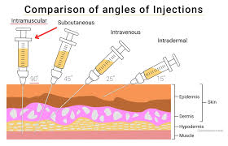
Steps to the Activity

Preparation
Each participant should have:
• Injection practice pad, orange, or manikin access
• Sterile water vial
• Syringe and needle
• Alcohol swab
• Gloves
Ask participants to put on gloves.
Explain that glove requirements vary between healthcare facilities. Some facilities require gloves for all injections, while others have more specific policies depending on the procedure and patient situation.
For further engagement, participants may choose a name for their simulated patient.

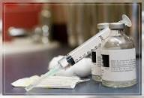
Medication Preparation
- Explain that the physician has ordered 1 mL of a simulated antibiotic injection.
- Instruct participants to perform hand hygiene and apply gloves if desired.
- Have participants remove the protective plastic cap from the vial if it is being used for the first time.
- Wipe the rubber stopper of the vial with an alcohol swab.
- Explain that many medications and vaccines are supplied in multi-dose vials and that the stopper must be disinfected each time medication is withdrawn.
- Discuss how some medications come in prefilled syringes rather than vials.

Drawing up Medication
- Remove the needle cap carefully and place it aside.
- Explain that the needle is sterile and sharp.
- Have participants pull back on the plunger to draw 1 mL of air into the syringe.
- Explain that when withdrawing medication from a vial, air is injected to replace the volume of fluid being removed.
- Insert the needle straight through the center of the vial stopper at a 90-degree angle.
- Inject the air into the vial.
- Turn the vial upside down while keeping the needle inserted.
- Slowly withdraw approximately 1 mL of solution.
- Explain that it is acceptable to initially draw slightly more than the ordered amount.
- Demonstrate removal of air bubbles by gently flicking the syringe with a fingernail.
- Advance the plunger to remove excess fluid and achieve the exact prescribed dose.

Administering the Injection
- Clean the injection site on the practice pad, manikin, or orange using an alcohol swab.
- Allow the area to dry briefly.
- Position the needle at a 90-degree angle to the injection surface.
- Insert the needle into the simulated muscle.
- Slowly inject the medication.
- Explain that some medications must be administered slowly because they can cause discomfort or burning.
- Remove the needle safely.

Needle Safety Device Activation
- Demonstrate activation of the needle safety device.
- Have participants engage the safety feature using the manufacturer’s instructions.
- Place the protected needle directly into the sharps container.
- Explain that modern safety devices significantly reduce occupational needle stick injuries.
- Reinforce that needles should never be recapped after use.

Safety / Protocols / Special Considerations

Needle and Sharps Safety
• Treat every needle as if it were contaminated.
• Never point a needle toward another participant.
• Never engage in horseplay while handling sharps.
• Keep hands behind the needle tip whenever possible.
• Activate needle safety devices immediately after use.
• Never recap needles after use.
• Dispose of all needles directly into an approved sharps container.
• Report any accidental needle stick immediately to the facilitator.
• Closely supervise younger participants.

Medication Safety Discussion
• This activity uses sterile water only.
• No medications should be administered to actual people.
• Reinforce the importance of verifying patient identity and medication orders in healthcare settings.
• Discuss how medication errors can impact patient safety.

Accessibility Adaptations
• Participants uncomfortable handling needles may observe portions of the activity.
• Facilitators may demonstrate steps while participants provide verbal instructions.
• Larger demonstration equipment may be used for visual learners.
• Additional facilitator assistance may be provided when needed.
• Alternative observation roles may be offered when appropriate.
• Step-by-step printed instructions may support participants who benefit from written directions.

Audience Considerations
• Best suited for grades 8 through adult audiences.
• Younger participants may benefit from observation rather than direct needle handling.
• High school students often enjoy the realistic healthcare simulation aspects of the activity.
• Adult learners may benefit from advanced medication calculation and patient scenario components.
• Easily adapted for classrooms, camps, career fairs, and healthcare workforce programs.
• Can be scaled for both small and large groups.

Assessment of Success
Success may be measured by participants’ ability to:
• Identify multiple routes of medication administration
• Explain differences between common injection types
• Demonstrate safe medication preparation techniques
• Draw medication from a vial correctly
• Administer a simulated intramuscular injection safely
• Demonstrate proper sharps disposal procedures
• Describe careers that administer medications

Lessons Learned / Helpful Tips

Lessons Learned
• Participants are often surprised by how much preparation occurs before giving an injection.
• Drawing medication from a vial is frequently the most challenging step for beginners.
• Learners enjoy naming their patient and treating the activity as a realistic clinical scenario.
• Older students often engage more deeply when medication calculations are incorporated.
• Simulated medication administration creates valuable discussions regarding patient safety and medication errors.
• Healthcare facilities often donate expired syringes, needles, gloves, sterile saline, and sterile water vials that work perfectly for educational activities and career exploration programs.
• Must use sterile water, plain water may mold and cause mold issues in simulated injection pads.

Helpful Tips
• Have extra syringes available for participants who accidentally contaminate or bend needles.
• Use oranges when injection pads or manikins are unavailable.
• Demonstrate each step before asking participants to perform it.
• Keep sharps containers readily accessible.
• Use realistic patient scenarios to increase engagement and critical thinking.
●work in much smaller groups with younger students.

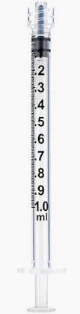
Alternate Activity Options

Basic Career Exploration Version
Participants practice drawing sterile water from a vial and administering a simple intramuscular injection into an orange or injection pad.
Best for:
• Middle school students
• Introductory healthcare career exploration
• Large career fairs

Medication Administration Record (MAR) Activity
Participants receive a patient chart containing:
• Patient name
• Medication order
• Medication administration record
• Simulated medication vial
Participants identify the correct medication, dose, and route before administering the injection.
Best for:
• High school healthcare students
• CNA classes
•HOSA activities
• Adult healthcare career exploration

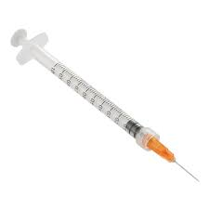
Dosage Calculation Challenge
Provide multiple strengths of the same simulated medication.
Participants calculate the correct amount to withdraw before administering the injection.
Best for:
• Advanced high school students
• College healthcare students
• Adult learners

Pediatric Patient Scenario
Provide a patient case involving a child who is unable to tolerate oral medication due to vomiting and now requires an intramuscular penicillin injection.
Participants review the scenario, determine the correct medication and dose, prepare the injection, and administer the simulated medication.
This version encourages critical thinking while introducing real-world clinical decision-making concepts.

Conclusion

Closing Discussion
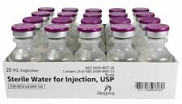
Discuss how medication administration is a common responsibility across many healthcare careers and how patient safety remains the highest priority.
Reinforce the importance of:
• Proper medication preparation
• Accurate dosing
• Infection prevention
• Sharps safety
• Communication and teamwork
Encourage participants to consider how healthcare professionals use these skills every day to improve patient outcomes and provide safe, effective care.

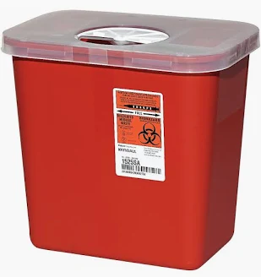
Clean Up
• Dispose of needles in approved sharps containers.
• Discard used alcohol swabs and waste materials.
• Wipe down work surfaces.
• Return reusable equipment to storage.
• Restock supplies for future events.

Storage and Transport Notes
• Transport sharps containers securely.
• Keep syringes and needles organized in labeled containers.
• Protect manikins and injection pads during transportation.
• Store supplies away from extreme temperatures.
• Verify adequate inventory before traveling to outreach events.

