Medical Coding Career Exploration Activity
Activity title: Medical Coding Career Exploration hands-on activity.
Date: June 2026

Overview
This activity introduces participants to the role of a Medical Coder and explores how healthcare encounters are translated into standardized codes used for insurance billing, reimbursement, healthcare data collection, and patient record documentation.
Participants will locate diagnosis and/or procedure codes using ICD-10 and CPT coding resources while learning how coding professionals review provider documentation for completeness and accuracy. Through the use of unusual and engaging diagnosis examples, participants gain insight into the investigative, detail-oriented nature of medical coding and the important role coders play within the healthcare system.
This activity can be adapted for brief career fair interactions lasting only a few minutes or expanded into a more in-depth classroom activity involving documentation review, coding requirements, and discussion of healthcare reimbursement processes.

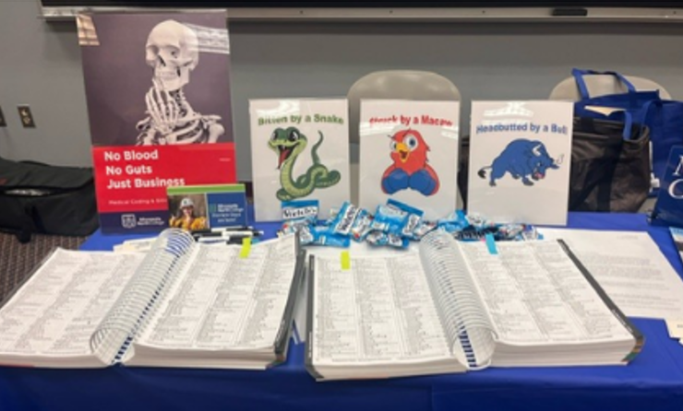
Careers Associated:
- Medical Coder
- Certified Professional Coder (CPC)
- Certified Coding Specialist (CCS)
- Certified Coding Associate (CCA)
- Risk Adjustment Coder
- Surgical Coder
- Pathology Coder
- Oncology Coder
- Medical Coding Auditor
- Coding Compliance Specialist
- Medical Billing and Coding Specialist

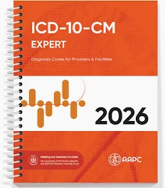
Supplies Required

General Setup
- Tables or work surface
- Multiple ICD-10 coding books
- Multiple CPT coding books
- Sticky tabs or page markers
- Plastic document holders or display stands
- Full-color diagnosis illustrations or signs
- Sample provider documentation notes
- Pens, pencils, or highlighters (optional)
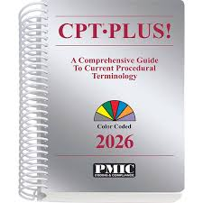
- Career pathway handouts (optional)

Per Participant
- Access to ICD-10 coding book
- Access to CPT coding book
- Sample diagnosis scenario
- Sample provider note (advanced version)

Time Required

Quick Career Fair Version
Setup: Approximately 5 minutes
Introduction: 1 minute
Code Location Activity: 1-2 minutes
Career Discussion: 1-2 minutes

Total Estimated Time: 3-5 minutes

Classroom/Camp Version
Setup: Approximately 10 minutes
Introduction and Career Discussion: 5 minutes
Code Location Activity: 10 minutes
Documentation Review Activity: 10-15 minutes
Wrap-Up Discussion: 5 minutes

Total Estimated Time: 25-35 minutes

Advanced Documentation Review Version
Introduction and Career Discussion: 5-10 minutes
Coding Activity: 10-15 minutes
Documentation Analysis: 15-20 minutes
Discussion and Debrief: 5-10 minutes
Total Estimated Time: 30-45 minutes

Target Audience:
- Recommended for grades 7-adulthood
- Intended primarily for Healthcare Career exploration.

Learning Outcomes:
Participants will:
- Describe the role of a Medical Coder within the healthcare system.
- Locate diagnosis and/or procedure codes using coding resources.
- Explain the importance of accurate provider documentation.
- Differentiate between Medical Coding and Medical Billing.
- Understand how coding impacts insurance reimbursement and healthcare operations.
- Explore education pathways, certifications, and advancement opportunities within the coding profession.
- Identify workplace settings where Medical Coders are commonly employed.
- Recognize the importance of accuracy, attention to detail, and problem-solving skills in medical coding careers.

Lessons Learned / Helpful Tips

Lessons Learned
- Students are often surprised to learn that Medical Coders can play an important role in healthcare without providing direct patient care.
- Unusual or humorous diagnosis examples such as Struck by a Macaw, Bitten by a Pig, Headbutted by a Bull, or Human Stampede consistently increase participant engagement and curiosity.
- Participants frequently discover that medical coding involves much more problem-solving and investigation than they initially expected.
- Students who enjoy computers, organization, attention to detail, puzzles, and critical thinking often express interest in the profession after completing the activity.
- Many participants are surprised to learn that Medical Coders commonly work remotely or in hybrid positions, allowing them to work from home.
- The activity creates valuable discussions about the importance of accurate documentation and how incomplete provider notes can impact coding and reimbursement.
- Working in pairs or small groups often encourages discussion and collaboration while allowing participants to learn from one another.
- Older editions of ICD-10 and CPT coding books work exceptionally well for career exploration activities and educational demonstrations. The most current editions are not necessary for this activity.
- Local healthcare organizations, clinics, hospitals, and Medical Coders are often willing to donate outdated coding books when new editions are released annually. Many coding professionals are enthusiastic about supporting healthcare career exploration and helping students learn about the profession.
- This activity is highly adaptable and can be successfully implemented as a brief 3–5-minute career fair activity or expanded into a 30–45-minute classroom lesson.

Helpful Tips
- Place sticky tabs on commonly used diagnosis pages before participants arrive to reduce search time.
- Laminate diagnosis illustrations or place them in plastic document holders to improve durability and presentation.
- Keep multiple coding books available when working with larger groups.
- Encourage participants to work in pairs when books are limited.
- Select unusual diagnosis examples that generate curiosity and conversation.
- For advanced participants, provide mock provider notes with intentionally missing information and challenge students to identify documentation deficiencies.
- Consider inviting a local Medical Coder as a guest speaker to discuss their career path, certifications, and daily responsibilities.
- If available, display multiple versions of coding books to demonstrate how coding resources are updated regularly as healthcare documentation and coding requirements evolve.
- Emphasize that accuracy is often more important than speed in medical coding, as coding errors can impact patient records and reimbursement.

