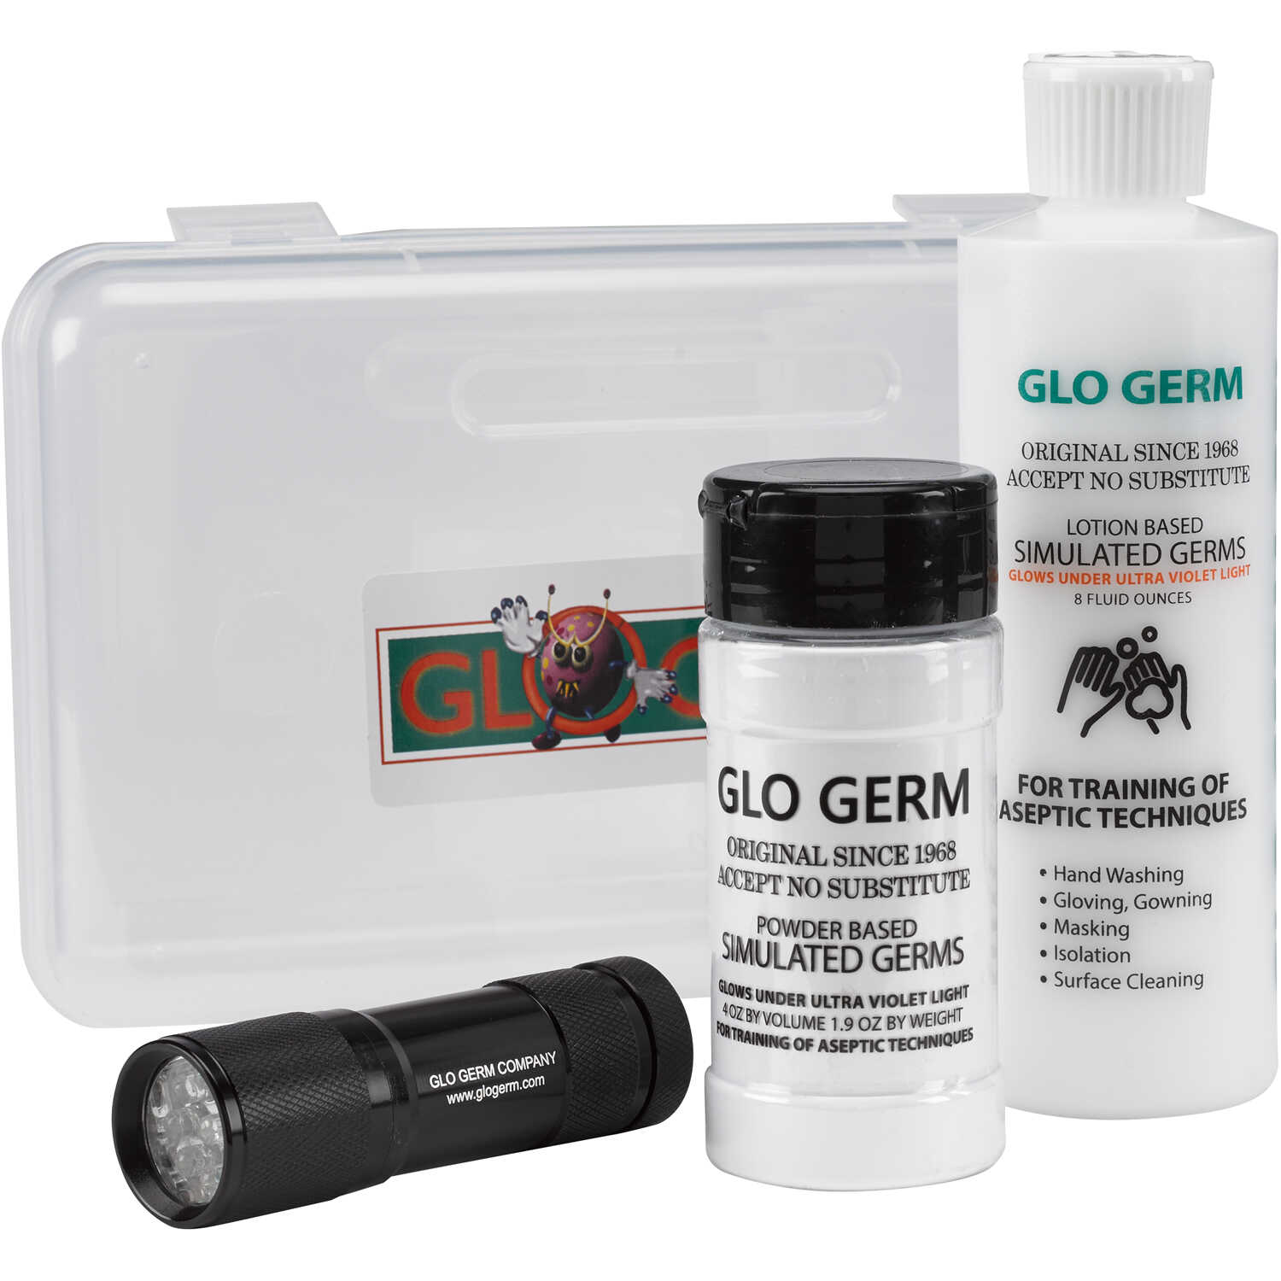
Glow Germ Handwashing Activity
Date: June 2026

Overview
Summary
This activity introduces participants to infection prevention, disease transmission, and proper hand hygiene techniques through the use of Glow Germ lotion or powder and ultraviolet (UV) light. Participants are able to visualize contamination that would normally be invisible to the naked eye, creating a memorable and impactful learning experience.
The activity demonstrates how microorganisms can spread between individuals and surfaces while reinforcing the critical role of hand hygiene in preventing healthcare-acquired infections (HAIs). Participants explore how proper handwashing practices protect patients, healthcare workers, families, and communities. The lesson also introduces the importance of infection prevention across all healthcare careers.

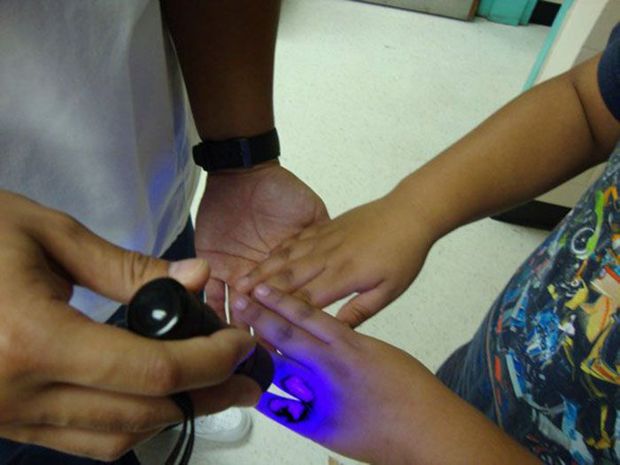
Careers Associated
All Healthcare Careers

Supplies Required
General Setup
• Tables or large work surface
• Glow Germ lotion (recommended)
• Glow Germ powder (optional for alternative activities)
• UV viewing box/station and/or handheld blacklight
• Access to sink with running water, Hand soap and paper towels
• Soap
• Paper towels
• Cleaning supplies
• Trash can
Per Participant
• Glow Germ lotion or powder application
• Access to handwashing station
• Paper towels for drying hands

Time Required
• Setup: Approximately 5-10 minutes prior to participant arrival
• Instruction/Demonstration: Approximately 3 minutes
• Activity: Approximately 10-15 minutes depending on sink availability and group size
• Initial Cleanup on Site: Approximately 2–3 minutes
Total Estimated Time: Approximately 10–15 minutes including discussion and cleanup.

Target Audience
• Recommended for kindergarten through adulthood
• Appropriate for healthcare career exploration activities
• Suitable for elementary, middle school, high school, college, community outreach, and adult audiences
• Safe and engaging for participants of all ages

Learning Outcomes
Participants will:
• Demonstrate proper handwashing technique
• Identify areas commonly missed during handwashing
• Explain how germs and pathogens spread between individuals and surfaces
• Understand the role of hand hygiene in preventing healthcare-acquired infections
• Recognize the importance of infection prevention in healthcare settings
• Explore how infection prevention impacts patient safety across all healthcare careers

Setup
• Arrange participants around a table, sink, or handwashing station.
• Ensure UV viewing equipment is charged and operational.
• Verify access to soap, running water, and paper towels.
• Organize supplies so participants can move efficiently through the activity.
• If using a viewing box, position it where participants can easily observe results.
• Test UV equipment prior to participant arrival.
Plan to have an area where lights could be turned off or dimmed for easier viewing of simulated germs.

Introduction
Explain to participants that healthcare professionals perform hand hygiene countless times each day because it is one of the most effective methods for preventing disease transmission.
Discuss how microorganisms are often invisible but can easily spread through contact with people, surfaces, equipment, and shared objects. Introduce the concept of healthcare-acquired infections and explain how proper handwashing helps protect patients and healthcare workers.
Emphasize that regardless of career pathway, infection prevention is a responsibility shared by all healthcare professionals.

Steps to the Activity
Activity Option A: Traditional Handwashing Demonstration
1. Apply a small amount of Glow Germ lotion to participant hands.
2. Have participants rub hands together thoroughly, can also suggest scratching palm surface with fingernails.
3. View hands under UV light.
4. Discuss how contamination can be present even when hands appear clean.
5. Have participants wash hands using soap and water.
6. Encourage proper handwashing technique including fingertips, thumbs, between fingers, and wrists.
7. Recheck hands under UV light.
8. Discuss areas where contamination remains and opportunities for improvement.
Activity Option B: Handshake Transmission Activity
1. Apply Glow Germ to one participant.
2. Have participants shake hands with several classmates.
3. Observe contamination spread under UV light.
4. Discuss how quickly germs can spread through routine contact.
5. Connect findings to patient interactions and healthcare environments.
Activity Option C: Shared Object Activity
1. Apply Glow Germ to a frequently touched object.
2. Allow participants to handle the object naturally.
3. View contamination spread under UV light.
4. Discuss high-touch surfaces and the importance of environmental cleaning.
5. Connect findings to healthcare equipment and patient care environments.

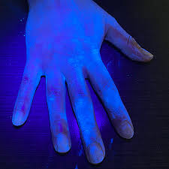
Safety / Protocols / Special Considerations
Glow Germ Safety
• Avoid contact with eyes and mouth.
• Participants should wash hands after the activity.
• Follow manufacturer recommendations for all Glow Germ products.
• Consider participant sensitivities to lotions or skin products.
UV Light Considerations
• UV viewing may require a darkened room or enclosed viewing box.
• Ensure equipment is functioning properly before beginning.
Participant Safety
• Younger participants may require additional supervision.
• Encourage participants to avoid touching faces during the activity.
• Maintain adequate access to sinks and handwashing supplies.

Accessibility Adaptations
• Participants uncomfortable with direct participation may observe.
• Facilitators may demonstrate portions of the activity.
• Visual components support a variety of learning styles.
• Additional facilitator assistance may be provided for younger participants.
• Alternative observation roles may be offered when appropriate.

Audience Considerations
• Appropriate for kindergarten through adult audiences.
• Particularly effective with elementary and middle school students.
• Provides a safe alternative for younger students when hands on activities including needles etc. would not be appropriate.
• Easily adapted for healthcare career fairs, camps, classrooms, and community events.
• Can be scaled for both small and large groups.

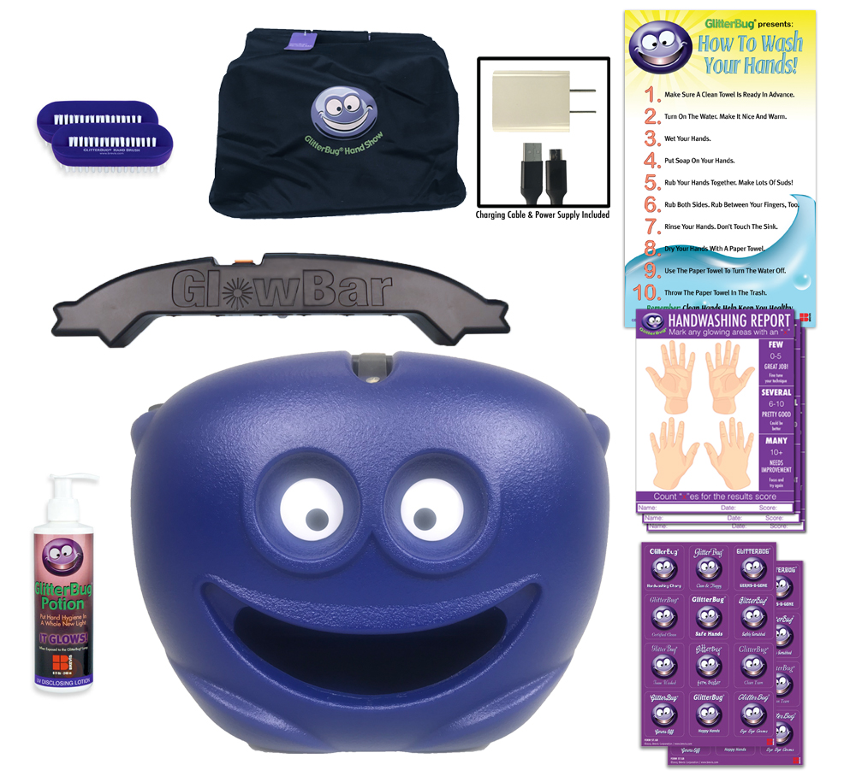
Assessment of Success
Success may be measured by participants’ ability to:
• Identify commonly missed handwashing areas such as fingertips, around fingernails, between fingers, thumbs, and wrists.
• Explain how germs spread through direct and indirect contact.
• Demonstrate proper handwashing technique.
• Describe the importance of infection prevention in healthcare.
• Connect hand hygiene practices to patient safety and healthcare careers.
• Demonstrate increased awareness of disease transmission.

Lessons Learned / Helpful Tips
Lessons Learned
• Students are often surprised by how much contamination remains after handwashing.
• Fingertips, around fingernails, between fingers, thumbs, and wrists are commonly missed areas.
• The handshake transmission activity consistently generates high engagement.
• Participants often remember this activity long after the event when performing handwashing.
• The activity creates meaningful discussions about patient safety and infection prevention.
• This activity works exceptionally well with younger students and audiences where activities involving needles would not be appropriate.
Helpful Tips
• Keep extra batteries available for handheld blacklights.
• Charge UV viewing units prior to events or ensure access to electrical outlet.
• Glow Germ lotion is highly portable and ideal for classroom visits.
• Glow Germ powder works particularly well with stuffed-animal activities and younger learners.
• Conduct a quick equipment check before participants arrive to avoid interruptions.

Alternate Activity Options

Handshake Transmission Demonstration
This variation works well as an introductory activity and effectively demonstrates how quickly germs can spread through person-to-person contact.
- Prior to participant arrival, apply a generous amount of Glow Germ lotion to one participant's hands (or select a volunteer as students enter the room).
- Have the participant shake hands with classmates as they enter or move around the room.
- Once all participants are seated, explain that no one was aware who had "contaminated" hands.
- Use a UV blacklight or viewing station to examine participants' hands.
- Discuss how contamination spread throughout the group without being visible.
- Connect the demonstration to real-world disease transmission and the importance of hand hygiene in healthcare settings.
- Have participants thoroughly wash their hands and recheck them under UV light to evaluate handwashing effectiveness.
Discussion Points:
- How quickly did contamination spread?
- Would participants have known they were exposed without the UV light?
- How does this relate to healthcare workers caring for multiple patients throughout a shift?

Infected Stuffed Animal / Shared Object Demonstration
This activity is particularly effective with elementary-aged students and younger audiences.
- Prior to the activity, apply Glow Germ powder to several stuffed animals, toys, or props.
- Leave one stuffed animal or object completely free of Glow Germ powder.
- Arrange participants in a circle and allow them to pass the objects around the group.
- After several minutes of interaction, use a UV light to examine participants' hands and the objects.
- Show participants that the previously "clean" stuffed animal is now contaminated due to repeated handling by individuals who touched contaminated objects.
- Discuss how germs can spread through shared items, equipment, toys, classroom materials, and healthcare equipment.
- Have participants wash their hands thoroughly and recheck for remaining contamination using UV light.

Discussion Points:
- Which object started out free of contamination?
- How did it become contaminated?
- What types of shared objects might spread germs in schools, homes, and healthcare facilities?
- How can handwashing help prevent this type of transmission?

Facilitator Tip
Many facilitators choose to begin with the Handshake Transmission Demonstration and then transition into the Traditional Handwashing Activity. This combination creates a highly engaging visual demonstration of disease transmission while reinforcing proper hand hygiene techniques and patient safety concepts.
Conclusion
Closing Discussion
As participants complete the activity, discuss how proper hand hygiene directly impacts patient outcomes and healthcare quality.
Encourage participants to consider how seemingly simple tasks such as handwashing can have significant effects on patient safety, disease prevention, and overall healthcare quality. Reinforce that infection prevention is a critical responsibility shared by every healthcare professional regardless of specialty or role.

Clean Up
• Dispose of paper towels and waste appropriately.
• Wipe down surfaces as needed.
• Power off UV equipment.
• Recharge equipment as necessary.
• Restock supplies before the next event.
• Verify all materials are ready for future use.

Storage and Transport Notes
• Transport Glow Germ products securely.
• Protect UV equipment during transportation.
• Charge rechargeable equipment before events.
• Store supplies away from extreme temperatures.
• Verify batteries are available for handheld UV lights.

