



COVID-19 Return to Campus Plan and Related Protocols

Fall 2020

Original 5.20.20

Revised 7.08.20

Revised 7.30.20

Revised 8.24.20

Table of Contents

**PLAN OVERVIEW** 3

**RETURN TO CAMPUS AND INSTRUCTION** 4

Health Screening Tool……………..………………………………………………………………………………………………….4

Campus Entrances………………………………………………………………………………………………………………………6

Face Coverings…………………………………………………………………………………………………………………………….7

Plexiglass Shields…………………………………………………………………………………………………………………………8

Building Cleaning and Disinfecting Protocols………………………………………………………………………………9

Public Space Protocols………………………………………………………………………………………………………………..9

Individual Workspace Protocols………………………………………………………………………………………………….9

Campus Traffic Control…………………………………………………………………………………………………………..…10

Restrooms…………………………………………………………………………………………………………………………………10

Meetings…………………………………………………………………………………………………………………………………..10

Classes, Activities and Gatherings……………………………………………………………………………………………..10

**USE OF SPACE PROTOCOLS**...............................................................................................................10

External Requests for Space………………………………………………………………………………………………………10

Tenants with Long-Term Leases………………………………………………………………………………………………..10

**COVID-19 MONITORING, TESTING AND REPORTING** …………………………………………………………..10

Symptom Monitoring………………………………………………………………………………………………………………..11

COVID-19 Testing and Reporting……………………………………………………………………………………………….11

Quarantine and Isolation Protocols…………………………………………………………………………………………..12

Contact and Communication Protocols……………………………………………………………………………………..13

**COMMUNICATION** ………………………………………………………………………………………………………………………….14

**Personal Health and Safety Guidance** ……………………………………………………………………………………………….15

**Workforce Development Safety Protocols** 19

**Decisions and Responses Related to Positive Campus COVID-19 Cases and Changes in Community Spread** …………………………………………………………………………………………………………………………….20

**PLAN OVERVIEW**

**This plan is designed to outline the coordinated planning and protocols that the college will use to ensure that employees and students have a safe environment to work and visit and learn. Protocols are rooted in safety for staff, faculty, students, invited guests (e.g., contractors) and for the public we interact with using guidance from the Minnesota State system office, Minnesota Department of Health, The Office of Higher Education, the Centers for Disease Control and the governor’s executive orders. Protecting the health of the M State community will require long-term effort and commitment, cooperation, teamwork and understanding.**

As we confront the continuing changes caused by the COVID-19 pandemic, M State will remain focused on our mission and values as outlined in the Strategic Plan. Strategic Plan activities are any required on-campus activities that fulfill M State’s core pillars of student success, equity and inclusion, and financial sustainability.

Radically different ways of deploying M State campus resources, including physical spaces, will be necessary as part of establishing a new normal. As we move forward, flexibility will be critical. M State’s return to instruction and services on campus will involve the careful evaluation of data, models and public health recommendations. Protocols will be pragmatic and evolve over time.

M State’s plans for expanding operations and increasing the presence of faculty, staff and students will be guided by the following criteria:

* The very intentional effort by all faculty, staff and students in exercising both personal and campus responsibility. The combined efforts by all members of the M State community will create a culture that sustains a healthy and safe on-campus environment.
* Existing and projected government restrictions (e.g., masking requirements, physical distancing, gatherings, etc.).
* Public health status: recommendations from the federal government, Centers for Disease Control and Prevention and Minnesota Department of Health.
* Resource availability including PPE (personal protective equipment) for students, faculty and staff.
* Physical distancing strategies.
* Financial feasibility.
* Alignment with M State’s strategic plan that the ramp-up of on-campus activities will support primary mission objectives of the college.

M State’s plans will also consider local orders and ordinances of the cities and counties in which our campuses are located, as well as the State of Minnesota.

The M State plan acknowledges the triggers and phases for the cities in which M State is located and identifies which activities ramp up or dial back on campus and when. If metrics of COVID-19 transmission and health system capacity change significantly and the State of Minnesota returns to a prior phase, M State may also return to a prior phase and re-impose restrictions on activities.

M State also may need to scale back in-person operations if transmission increases, by reducing or cancelling campus events; suspending in-person classes; or moving to remote-only operations as a result of a significant outbreak on campus or in the surrounding community, or if directed by public health authorities. The mitigation strategies are outline in Attachment C. In addition to ongoing communication with public health officials, changes in two or more of the indicators in each level will initiate conversations between colleges and universities and the system office to determine additional mitigation measures.

**RETURN TO CAMPUS AND INSTRUCTION**

As we bring students back on campus this fall, and employee and visitor traffic increases there is a need for protocols to ensure the health and safety of employees, students, visitor and contractors. In order to allow as many programs back as possible, compliance with the policies and protocols are required for continued access; violations (e.g., blatant disregard for infection prevention measures) may result in the revocation of building access privileges.

**Health Screening Tool**

All employees, students, visitors, and contractors are required to complete a self-screening tool daily before they can enter the campus.

The screening tool will ask if you have any of the COVID-19 related symptoms, or if you have been in recent close contact with a person who tested positive. If you answer no to all the questions, a green screen will display on your electronic device that can be used to verify you passed the self-screen. An email will also be sent to your email account. All students and employees will use their StarID to log into the tool. Visitors and contractors will have to enter their name and email address. Because the green screen is not retained for the entire day, a screen shot of the results should be taken, or an email will be sent and that can be used to show verification of completing the tool, should you need it.

As stated above, students will be required to complete the tool daily and will need the green screen verification should they be asked by any employee to see it. If they do not have a mobile electronic device to use, they will need to print out the email as proof.

If either an employee or student answer yes to any of the questions they will receive a red screen which will tell them not to come to campus, and will also include instructions to quarantine, contact health care providers as needed, and who on the campus to notify.

A database of those that completed the self-screening will be kept and only limited college staff will have access to it. We will use the data to estimate the number of employees and students that completed the self-screen against the number we feel should be on campus to determine if students are completing the requirement. The only other reason we will use the data is if we need to work with the Minnesota Department of Health and do contact tracing or notification in the event of a positive case.

The tool can be accessed in several places including the employee portal, the college home webpage, the coronavirus web page, or by the QR code below which is also located at all entrances. To use the QR code you will need to download a QR Reader app from the app store on your electronic device.

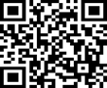

There will be a kiosk set up at the front entrance of each campus in the event visitors or contractors need to complete the self-screening. They will be allowed to enter the campus but will need to immediately complete the self-screening before going any further. M State kiosks and printers will be available at the following entrances on campus:

Detroit Lakes-E5

Fergus Falls-C300A

Moorhead-N2 and W1

Wadena-W2

If you have visitors (including prospective students) or contractors that you are inviting on to campus, make sure that they are aware of this requirement so that they can complete the self-screening prior to the appointment.

All individuals that enter the campus through the main public entrance will be required to verify they have taken and passed the self-screening. Students that enter the campus directly through their program area, or entrances near their program space will be reminded to complete the screening tool by signage and faculty. Program faculty may require all students to verify they have taken the self-screening tool and passed if they chose to do so.

We will monitor the number of students that completed the screening tool daily and compare that number with our estimate of how many students were likely on campus based on expected class attendance to ensure that they are completing it. If the numbers show that many students are not completing the screening tool, we will move to a more rigorous process to ensure they complete it daily.

As with any screening tool, this one is reliant on everyone being truthful about their health. And, as we know people can be asymptomatic and carrying the virus without knowing it, so no screening tool gives us 100% assurance that no student or employee has the virus. Because of that, it will be important for all of us to remind students to maintain social distance and to wear a face covering as required by the Governor’s Executive Order.

**Campus Entrances**

As traffic increases on campus, there is a need for protocols as to how each of those groups enter the campus. These protocols will be used to keep students socially distant from one another and continue to remind them to complete the symptom screening tool daily.

Employee entrance

Employees may enter any door that is convenient to them once they have completed the self-screening tool.

Student entrance

There are several of the main campus entrances open for student traffic. There are signs on the doors that direct the general public to enter through the main entrance(s).

Where possible, students will enter their program lab/classroom through either the exterior lab entrance or a main corridor entrance as near the lab as possible. This will reduce any congestion at the main entrance(s) and allow for student social distancing. In addition, by entering directly into their program space, and not having to move throughout the campus, the risk of students infecting each other will be reduced.

If programs are located in the interior of the building, students should use the student entrance closest to the program classroom to limit students moving around campus as much as possible.

Students will be notified which parking lot to use to reduce the distance they have to walk to get into the building.

Signs will be placed on all entrances to remind students to complete the screening tool prior to entering the building.

Program faculty are asked to remind the students that they need to complete the screening tool and if they have any symptoms to leave the class and follow the MDH protocol for quarantining.

If individual faculty wish, they can ask each member of the class to show them the “green screen” from the screening tool (or a paper printout) which verifies they answered “no” to all the screening questions.

The screening tool will keep a roster of all students that have completed it, so there will be no need to have students check in or to take attendance.

In addition to the main public entrances noted below we will be opening up additional entrances for student entrance only. Those entrances will be unlocked but signed for student entrance only and that visitors and contractors should enter the campus through the main designated entrances.

Those additional student entrances are:

Detroit Lakes – N1

Fergus Falls – L100C, S400D, C300A, W600D

Moorhead – S3 and E2

Wadena – S3 and N1

Visitor and Contractor Entrance

All visitors and contractors will be required to enter the campus through the main entrance(s) and complete the self-screening tool if they have not done so already. Visitors will be limited to those individuals that have a business purpose to enter the campus which will include prospective students along with their family or friends that come with them. All employees that are inviting visitors (including prospective students) or contractors to the campus should notify them of the screening requirement so that they can complete it prior to arriving for the appointment, when possible.

Visitors and the general public will be directed to enter the campus through the main door. Those entrances are:

Detroit Lakes-E5

Fergus Falls-C300A

Moorhead-N2 and W1

Wadena-W2.

Detroit Lakes, Fergus Falls, and Wadena will be monitored by the resource specialist located at the reception desk. Because of Moorhead traffic a second door will also be open to the public and will be monitored by two reassigned employees.

**Face Coverings**

A “face covering” must be worn to cover the nose and mouth completely, and can include a paper or disposable face mask, a cloth face mask, a scarf, a bandanna, a neck gaiter, or a religious face covering. Masks that incorporate a valve designed to facilitate easy exhaling, mesh masks, or masks with openings, holes, visible gaps in the design or material, or vents are **not** sufficient face coverings because they allow exhaled droplets to be released into the air.

* Face masks/coverings **must** be worn by all **employees** at all times on campus in public settings (e.g., reception/receiving area, common workspaces, public spaces, hallways, stairwells, elevators, meeting rooms, classrooms, break rooms, in restrooms, etc.).
* Face masks/coverings **must** be worn by all **students, contractors, and members of the public** at all times on campus in public settings (e.g., reception/receiving area, common workspaces, public spaces, hallways, stairwells, elevators, meeting rooms, classrooms, break rooms, in restrooms, etc.).
* Face masks/coverings must be worn outdoors when it is not possible to maintain social distancing.
* Face masks/coverings are NOT required to be worn when an individual is alone, including when alone in an office, a room, a cubicle with walls that are higher than face level when social distancing is maintained, a vehicle, or the cab of heavy equipment or machinery, or an enclosed work area. In these situations, a face covering should be available and used when another person enters your work area.
* Children under the age of 2 are entirely exempt from the face covering requirement. Children under age 5, but at least 2 are strongly encouraged, but not required to wear face coverings.
* An employee who cannot wear a face mask/covering due to medical or disability reasons should contact Dacia Johnson, Chief Human Resources Officer for possible accommodation measures.
* Students who cannot wear a face mask/covering due to medical or disability reasons should contact their campus Accessibility Resource Officer for possible accommodation measures. Those individuals are:
  + Mark Nelson – Detroit Lakes campus
  + Jon Kragness – Fergus Falls campus
  + Jaime Jensen – Moorhead campus
  + Paula Rohr – Wadena campus
* Face Shields are permitted as alternative to a face mask/face covering in the following situations:
  + When faculty are teaching a class or giving a lecture, or when students are participating in classroom activities, where it is important for the face to be seen (for example, certain activities in language or communications classes).
  + Where a face covering may pose a hazard due to the nature of the class or activity (for example, in a laboratory component of a class).
  + When staff or faculty are providing direct support student services and a face covering impedes the service being provided.
  + For individuals who cannot wear a mask for a mental health condition, or disability.
* As per the system office face mask operating instruction compliance section:
  + Students who fail to comply with face covering requirements will be asked to leave class and report to the Campus Lead Contact at each campus.
  + Employees or students will report student non-compliance to the Campus Lead Contact at each campus.
  + Employees will report employee non-compliance to their supervisor who will work with the non-compliant employee’s supervisor.
  + The Campus Lead Contact for the above reporting purposes are:
    - Detroit Lakes – Karen Buboltz – 218.846.3714
    - Fergus Falls – Dr. Matt Borcherding – 218.736.1506
    - Moorhead – Carrie Ward – 218.299.6631
    - Wadena – Stephanie Drange – 218.631.7817

**Plexiglass Shields**

* Supervisors and the facility team will try to identify which workstations are student-facing and need a plexiglass shield to protect employees, students and visitors.
* The campus facility directors are responsible for ordering the needed shields. Employees should not order protective shields themselves and must go through a facility director.
* If you feel you need a protective shield and one has not already been installed, please contact your supervisor.

**Building Cleaning and Disinfection Protocols**

* Enhanced cleaning protocols are in place on campus for high-risk/high-touch areas (e.g., door handles, light switches, handrails, interior doors, door push plates, common spaces, flat surfaces such as tables, elevator buttons, and vending machines).
* Increased cleaning will be performed in restrooms in common areas.
* Hand sanitizer dispensers have been placed at entrance and exit points for buildings on campus, as well as throughout the campus.
* If an individual in a building tests positive for COVID-19, the immediate space(s) which the positive person occupied will be deep-cleaned based on CDC protocols and will be re-opened once sanitized.

**Public Space Protocols**

* Visual cues such as floor decals, colored tape or signs are placed in areas where lines are common to indicate where people should stand while waiting.
* Barriers to ensure social distancing are placed where space allows.
* Pens used by visitors or students will be given to the visitor/student to keep. Pens will not be shared.
* Public spaces are set up to ensure social distancing by removing chairs, computers, etc.
* Water fountains are disabled and clearly marked to state that only the bottle fill dispenser is operational.
* Facilities team continue to disinfect door handles and light switches on a regular basis several times per day.
* Certain areas/rooms of the campus will be restricted and clearly marked to limit the amount of the facility that needs to be disinfected daily.

**Individual Workspace Protocols**

* Plexiglass shields are installed on desktops identified as student-facing workspaces.
* Employees may request a shield if they want one.
* Physical barriers to ensure social distancing are placed where space allows.
* Alternative workspace locations may need to be established to ensure social distancing.
* Pens used by visitors or students will be given to the visitor/student to keep. Pens will not be shared.
* Guest chairs should be limited to one per workstation.
* No more than one other individual in your workspace unless a 6-foot separation can be established.
* Public materials (catalogs, brochures, etc.) will be removed from workstations and available on request only.
* Facilities will disinfect your workspace daily, however disinfecting during the workday and disinfecting your telephone, keyboard, etc., will be the responsibility of the employee.

**Campus Traffic Control**

* Employees should limit movement around the campus as much as possible by remaining in their workspace.
* One-way directional signage for spaces with multiple through-ways may be established to avoid meeting others within those areas.

**Restrooms**

* Restrooms have been modified to ensure physical distancing is achieved.

**Meetings**

* Meetings should remain virtual if possible, even if all participants are on campus.
* If it is not possible to meet virtually, all face-to-face meetings with other employees or students are required to maintain social distancing of 6 feet between individuals.

**Classes, Activities, and Gatherings on Campus**

* In‐person activities or classes of no more than 25 individuals or less (including students, faculty, and staff) are allowed when those services cannot be provided through a distance learning model. Social distancing must be maintained.
* Gatherings not associated with a class or structured event/meeting must not exceed 10 indoors and 25 outdoors.

**USE OF SPACE PROTOCOLS BY EXTERNAL ENTITIES**

**External Requests for Space**

* Use of space within buildings may be limited. All requests will be routed for review through the Lynn Kraft, Reservation Specialist.
* Use of outdoor space may be allowed based on the entity providing:
  + The safety protocols they will use to ensure social distancing;
  + A written plan provided to the college outlining the protocols;
  + No employee will be expected to assist the entity unless the employee volunteers.

**Tenants with Long-Term Leases**

* External organizations that lease space on a long-term basis will be allowed to continue operations with the expectation that they will follow our safety protocols.
* A copy of their safety protocol plan will be requested and reviewed by the director of safety and emergency preparedness to ensure that their protocols align with the campus plan. Unresolved discrepancies will be routed through the chief financial officer for consultation.

**COVID-19 MONITORING, TESTING AND REPORTING**

**Symptom Monitoring Requirement**

As noted under the Return to Campus and Instruction section, all employees, students and visitors will be required to complete a screening survey prior to being allowed into building.

If a student authorized to be on campus has concerns regarding their status, they should inform their instructor or dean that they are reviewing their health status prior to the start of any scheduled time on campus.

In order to ensure compliance with ADA requirements, records of symptom assessments should not be maintained by departments. Leave may be requested as provided by the respective bargaining unit provisions.

[According to the CDC](https://www.cdc.gov/coronavirus/2019-ncov/symptoms-testing/symptoms.html), symptoms may appear 2-14 days after exposure to the virus. These symptoms or combinations of symptoms include:

* Cough *Fever
* Shortness of breath or difficulty breathing *Chills
* Repeated shaking with chills *Muscle pain
* Sore throat *New GI symptoms
* New loss of taste or smell

If a faculty or staff member has any symptoms, including a fever of 100 degrees or greater, you must self-isolate until you are symptom-free or have negative COVID-19 test results. If the results are negative, you may return to campus without any formalized clearance and approval from your supervisor.

**COVID-19 Testing and Notifying**

Faculty and staff who have symptoms related to COVID-19 or determine that they need to be tested based on potential exposure are encouraged to contact their primary care provider, who may instruct the individual to go to a designated assessment site to be tested. Students who have symptoms related to COVID-19 or determine that they need to be tested based on potential exposure are also encouraged to contact their primary care provider.

Individuals who have symptoms or may have been exposed and are off campus should contact their primary care physician for COVID-19 testing locations in their area.

Below is a list of local facilities that are conducting COVID testing:

* Detroit Lakes
  + Essentia
  + Sanford
  + White Earth testing site
* Fergus Falls
  + Lake Region Healthcare
* Moorhead
  + Essentia, (Fargo)
  + Sanford (Fargo)
  + Family HealthCare (Fargo)
* Wadena
  + Tri County Healthcare

**Quarantine and Isolation Protocols**

M State will be following the guidance of the Minnesota Department of Health relative to how we handle positive test results and quarantine expectations for employees and students. The current requirements as set forth by the Minnesota Department of Health are:

If a student or employee has a confirmed positive test result, they must isolate until all three of the below indicators have been met:

* Quarantine for 10 days since they first became ill, or were notified of a positive test
* Symptoms have disappeared
* Not had a fever for the last 24 hours, without fever-reducing medications

If a student or employee is identified by the Minnesota Department of Health as a “Close Contact” or “Exposed Contact” they must:

* Quarantine for 14 days from likely date of exposure
* Even if the individual gets a negative test result within the 14 days, they must continue to quarantine throughout the 14 days
* Wearing a mask does NOT eliminate this requirement

MDH and CDC have defined a close contact or exposed contact as being within 6 feet of a positive case for 15 consecutive minutes.

Individuals that have had COVID-19 within the prior 3 months of the date they were potentially exposed, are not required to quarantine if they are considered a close contact. MDH will take that into consideration when they do their contact tracing.

Based on the Minnesota Department of Heath guidelines, employees or students that are not identified as “close contact” or “exposed contact” of a positive case but are within the same classroom or work area do not need to quarantine but should continue to monitor themselves for symptoms. If they develop symptoms they should immediately quarantine and contact their medical provider for further guidance.

**Contact and Communications Protocols**

The Minnesota Department of Health has a team set up to communicate positive test results and complete contract tracing. They have the responsibility in the case and contact tracing and are assisted by the County Public Health.

When an individual’s test result comes back positive, the contact team will interview the individual to determine who needs to be considered a close contact. The individual will also be asked if they attend a college or university and if their name can be shared to assist with the contact tracing. If the case load becomes very high, the college may also be asked to assist with contact tracing.

The goal of the Minnesota Department of Health is to contact the positive individual, any close contacts, and the college all with 24 hours of the test result being determined.

Each institution is required to have an MDH liaison and an alternate. The liaison will be the contact that will receive a notification when a positive case or close contact identifies that they attend M State. Pat Nordick with serve as the MDH liaison and Dacia Johnson as the alternate. We will be required to take calls from MDH 7 days a week to receive the notification of a positive test; assist MDH with locating information such as class lists, facility layout, employee rosters; or contact tracing should they need assistance.

When we are notified by MDH or the County Public Health of a positive case, we will set off our internal processes for notifying employees and other students that may have been in close proximity of the positive case. We will be in contact with the employee or student to learn more about when and where they have been on campus and take appropriate action to notify those individuals that are affected.

If you as an employee either test positive or are contacted by either the Minnesota Department of Health or the County Public Health that you have been identified as a close contact to a positive case we ask that you notify Dacia Johnson as well as your supervisor. In addition, if you are advised by your healthcare provider to isolate or quarantine please follow their professional advice. Dacia will contact you to get more information to assist us with any internal notifications we will need to make to other employees and/or students. With that information, we will work through our process of notifications.

If you get contacted by a student that they have tested positive or have been identified as a close contact and need to quarantine by the Minnesota Department of Health or the County Health Department, please forward that information immediately to Pat Nordick which will start the internal process of communication.

We will not receive notifications for employees or students living in North Dakota so we will be relying on the individuals themselves to let us know if they tested positive or need to quarantine. Again, if you receive notice from an employee or student please notify me so that we can start our internal process.

If a faculty, staff member or student believes they have contracted COVID-19 after exposure to a known positive case or are feeling symptoms, you must immediately remove yourself from campus, even if you are not showing symptoms. While you await test results, you must remain at home in self-isolation and keep your supervisor/dean informed of your return-to-campus status.

**COMMUNICATION**

This Plan, protocol, recommendations, training and communication will be updates as necessary. Communication to the campus community will be ongoing in the form of signage, College website and instructional emails.

This COVID-19 Back to Campus Preparedness Plan has been certified by Minnesota State Community and Technical College’s Executive Cabinet and will be posted to the College website.

Certified by:

Minnesota State Community and Technical College President

**Attachment A**

**Personal Health and Safety Guidance**

**Personal Safety Practices**

**Physical Distancing**

Maintaining space between you and others is a best practice and required on the M State campus to avoid exposure to the COVID-19 virus and slow its spread. Because people can spread the virus before they know they are sick, it is important to stay away from others whenever possible, even if you have no symptoms. Physical distancing is especially important for people who are at higher risk. Individuals on campus should follow these physical distancing practices:

* Stay at least 6 feet (about 2 arms’ length) from other people
* Do not gather in groups
* Stay out of crowded places and avoid mass gatherings

**Face Masks/Coverings**

A “face covering” must be worn to cover the nose and mouth completely, and can include a paper or disposable face mask, a cloth face mask, a scarf, a bandanna, a neck gaiter, or a religious face covering. Information on making your own face covering using CDC guidance is available at https://www.cdc.gov/coronavirus/2019-ncov/prevent-getting­sick/how-to-make-cloth-face-covering.html. Medical-grade masks and respirators are sufficient face coverings, but to preserve adequate supplies, their purchase and use is discouraged for those who do not work in a health care setting or in other occupations that require medical-grade protective equipment (*e.g.*, certain construction occupations). Masks that incorporate a valve designed to facilitate easy exhaling, mesh masks, or masks with openings, holes, visible gaps in the design or material, or vents are **not** sufficient face coverings because they allow exhaled droplets to be released into the air.

Appropriate use of face masks/coverings is important in minimizing risks to the wearer and those around them. You could spread COVID-19 to others even if you do not feel sick. The face mask/covering is not a substitute for physical distancing.

Each faculty, staff member and student must wear a face covering. You may wear homemade cloth face coverings that abide by CDC and other public health recommendations. There will be a limited number of disposable and cloth masks, if needed. Masks are also available for purchase at the bookstores. Disposable masks should only be worn for one day. See details regarding face mask/covering use and care below.

If an individual is having difficulty wearing a face mask/covering, contact your supervisor or student services for direction. A faculty or staff member who cannot wear a face mask/covering due to medical or other reasons should contact Human Resources for possible accommodation measures.  Students should contact Accessibility Resources for possible accommodation measures.

**Use and Care of Face Masks/Coverings:**

**Putting on the face mask/covering**

* Wash hands or use hand sanitizer prior to handling the face mask/covering.
* Ensure the face mask/covering fits over the nose and under the chin.
* Situate the face mask/covering properly with nose wire snug against the nose (where applicable).
* Tie straps behind the head and neck or loop around the ears.
* Throughout the process: Avoid touching the front of the face mask/covering.

**Disposal of face masks**

* Keep face mask stored in a paper bag when not in use.
* Disposable face masks must not be used for more than one day and should be placed in a trash receptacle.
* Dispose of a face mask if it is visibly damaged (e.g., stretched ear loops, torn or punctured materials), dirty or visibly contaminated.

**Taking off the face mask/covering**

* Do not touch your eyes, nose or mouth when removing the face mask/covering.
* When taking off the face mask/covering, loop your finger into the strap and pull the strap away from the ear, or untie the straps.
* Wash hands immediately after removing.

**Care, storage and laundering of cloth face coverings**

* Keep face covering stored in a paper bag when not in use.
* Cloth face coverings may not be used more than one day at a time and must be washed after use.
* Disinfecting method: Launder cloth face coverings with regular clothing detergent before first use and after each shift. (Disposable masks are not washable).

**Gloves**

Gloves are not necessary for general use and should not replace good hand hygiene. Washing your hands often with soap and water is considered the best practice for common everyday tasks. Please speak with your supervisor to determine if gloves are necessary.

**Goggles/Face Shields**

Individuals are not required to wear goggles or face shields as part of general activity on campus. Good hand hygiene and avoiding touching your face are generally sufficient for non-healthcare environments.

**Personal Disinfection**

Facilities will continue to clean office and workspaces, classrooms and public spaces based on protocols developed with CDC guidance in mind, and you should take additional care to wipe down commonly used surfaces after use. The college will make every effort to provide product for use in your personal workspace, however, demands on the supply chain may limit what we can provide. Before you leave any room in which you have been working or eating, it is recommended that you wipe down all work or eating areas with EPA-registered disinfectant. This includes a private workspace or any shared-space location or equipment (e.g., computers, A/V and other electrical equipment, copiers, desks and tables, chair arms, light switches, doorknobs, handles, etc.). To the best of your ability, you should clear desk and table surfaces in personal offices and workstations to aid in thorough cleaning. Using a hand sanitizer that contains at least 60 percent alcohol is also effective after contacting commonly used surfaces.

**Hand Washing**

Wash your hands often with soap and water for at least 20 seconds, especially after you have been in a public place, using the restroom, blowing your nose, coughing, sneezing or before and after eating. If soap and water are not readily available, use a hand sanitizer that contains at least 60 percent alcohol. Cover all surfaces of your hands and rub them together until they feel dry. Avoid touching your eyes, nose and mouth with unwashed hands.

**Coughing/Sneezing Hygiene**

If you are in a private setting and not wearing your face mask/covering, remember to always cover your mouth and nose with a tissue when you cough or sneeze, or use the inside of your elbow. Throw used tissues in the trash. Immediately wash your hands with soap and water for at least 20 seconds. If soap and water are not readily available, clean your hands with a hand sanitizer that contains at least 60 percent alcohol.

**Mental Health and Emotional Wellbeing**

M State is committed to supporting your overall health and well-being. Contact Human Resources for more information and resources to offer support, manage stress and enhance your resilience. For information on the Employee Assistance program follow the link <https://mn.gov/mmb/segip/health-and-wellbeing/eap/>

United Healthcare is offering an emotional support help line for all students through its Optum subsidiary at no cost to students. Their toll-free help line number is 86.342.6892 and is open 24 hours per day, seven days per week. Students have access to specially trained mental health specialists to support them if they feel they are experiencing anxiety or stress related to developments around COVID-19.

**Attachment B**

**Workforce Development Safety Protocols**

Students must enter through a designated door. The door will be determined by the Dean of Workforce Development based on location of the classroom or lab and communicated to the Facilities Director.

Students will be required to wear a mask.

Students will need to bring their own pencils and other supplies. There will be no shared supplies of any kind.

Student must bring their own lunch. No one can leave the building once they have been checked in.

Before entering the classroom, students will be required to:

* sign in
* complete the COVID screening document which could include temperature checks
* Place cloth mask on – students must bring their own. If they forget, one will be provided to them by the college
* use hand sanitizer

Students should remember:

* If you feel ill before class begins – stay home and contact instructor
* Cover their cough/sneeze with their sleeve or tissue – throw tissue immediately and clean hands
* No gathering in groups on break
* Maintain social distancing
* Wash hands or use sanitizer frequently throughout the day
* If you begin to feel ill during class, notify the instructor immediately

Prior to leaving the building at the end of class, students need to wash their hands or use hand sanitizer.

The instructor will ensure that a complete roster of students in the class will be maintained in case tracing or notifications are needed.

**Attachment C**

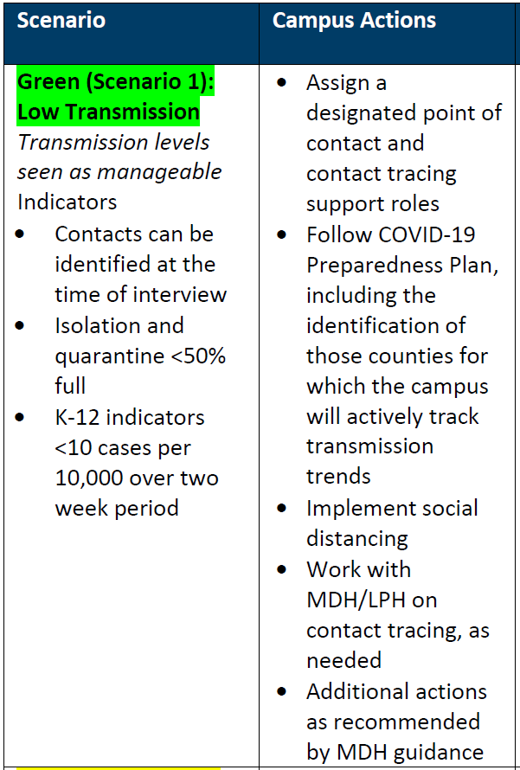**Decisions and Responses Related to Positive Campus COVID-19 Cases and Changes in Community Spread**

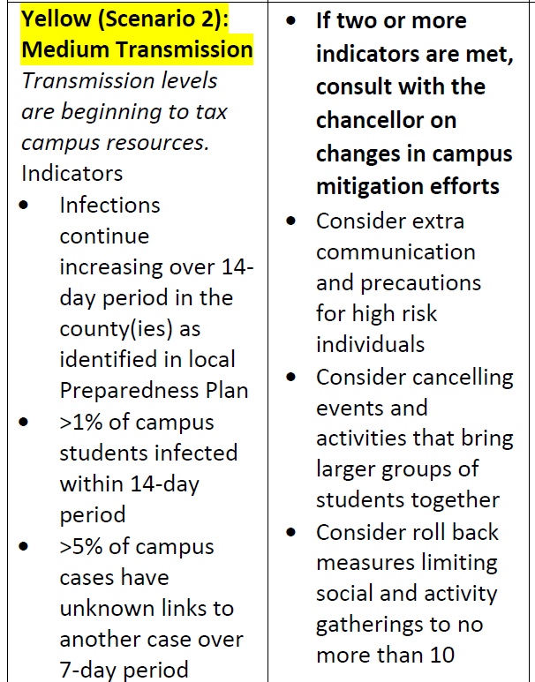

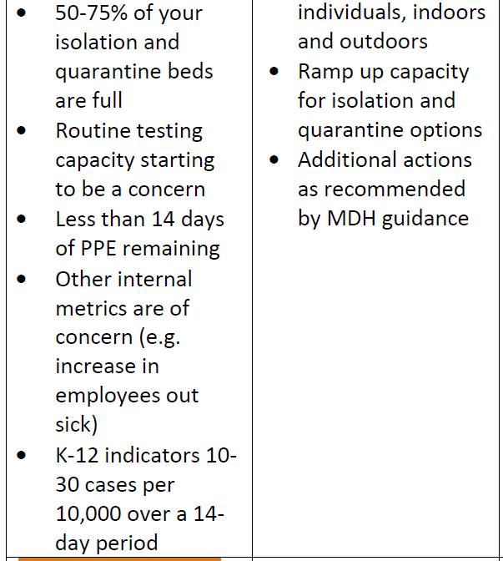

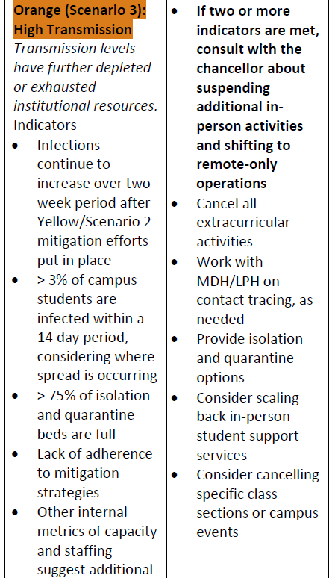

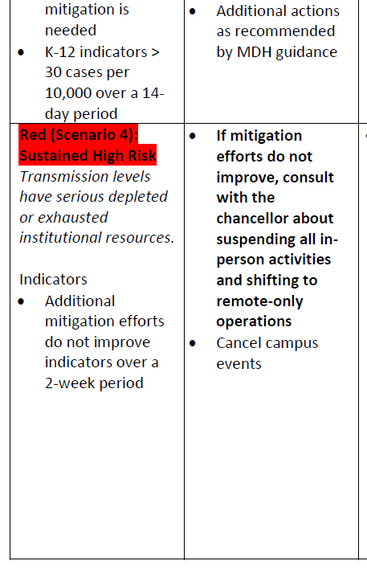

M State will actively monitor transmission levels on a weekly basis, and to take appropriate action as outlined above.